IS 312 Web Design and Programming
HOS01A: Getting to Know the Env

4/23/2026 Jonathan Koerber
09/15/2026 Reviewed by Akshita Modi

School of Technology & Computing (STC)
City University of Seattle (CityU)




Before You Start
- In this course, we are going to be using the cloud development environment provided by GitHub Codespaces. The primary reason for this is that it will be a constant environment, so we are sure that our code will run correctly. If you would prefer to work on your local machine, you may need to install some additional packages.
- Some steps may not be explained in detail. If you are not sure what Todo:
- Consult the resources from the course
- Consult an AI chat agent of your choice
- If you cannot solve the problem after a few tries, ask a TA for help

Learning Outcomes
- Become comfortable using GitHub Codespaces
- Learn how to incorporate AI tools to optimize learning.
- Create
Incorporating AI into your Learning Workflow
In this course, we embrace the future of development by incorporating tools like GitHub Codespaces and VS Code. Our goal is to use these tools not as "answer engines," but as Socratic Tutors.
The "Socratic Tutor" Philosophy
A Socratic tutor doesn't give you the answer; they ask the right questions to help you find the answer yourself. When using AI, your goal is to understand the logic, not just the output.
Guide for best results:
- Explain, Don't Replace: Use AI to explain error messages or logic. Never copy-paste code without being able to explain what every line does.
- Verify the Output: AI can sometimes "hallucinate" (make mistakes). Always compare the AI’s explanation with the actual results you see.
- Cite Your Assistant: If an AI helps you solve a particularly difficult bug, add a comment in your code like: # Logic assisted by AI to resolve non-numeric error.

In addition to writing out the code in this document, there are challenges that ask you to use AI to answer questions, record your answers in a challenge md or docx file or Markdown block in your notebook. Take note of whether the answer that you got back was what you expected and how you phrased your question to get the responses that you were looking for.

- Creating GitHub Codespace
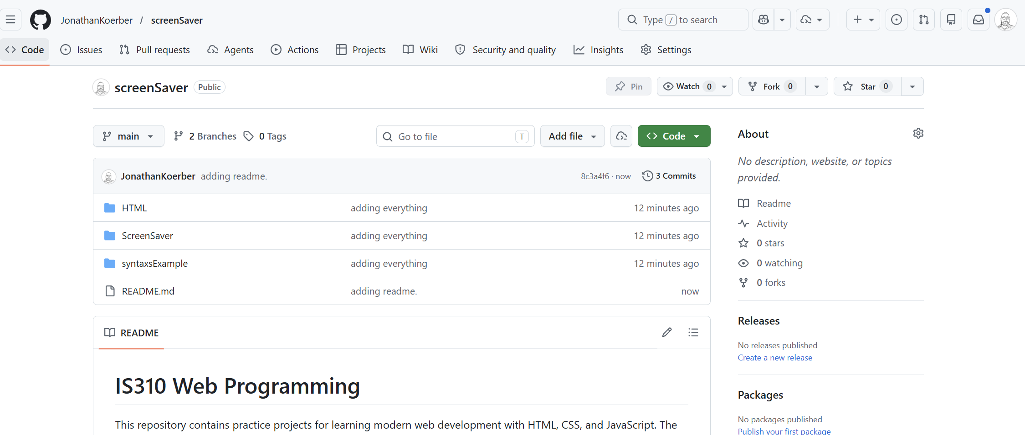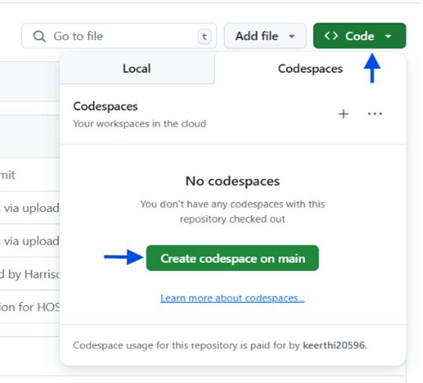
Navigate to your HOS and find the code button. Click on it and then click Create codespace on main. This will create a cloud development environment on the main branch.

- Wait for the GitHub Codespaces environment to load. Once loaded, you can access the terminal, File Explorer, and other tools to start working on your project. Your screen should look like the screenshot below. You can pick a theme that you like
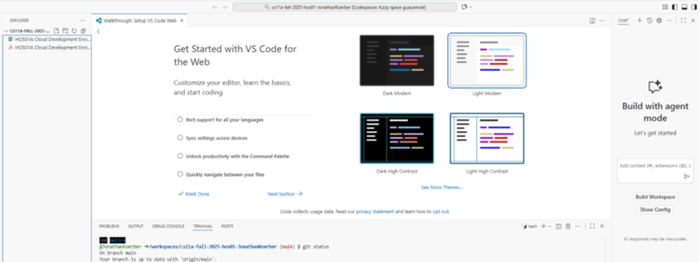
- Now we can see the major components that we are working with. GitHub Codespaces is a text edit for code files. In the left window, we can see that we have access to the file explorer showing the files that we have in the repository. The main window is where we edit files. In the Right-hand side of the page, we have a Copilot agent. Below the main window, you can see the terminal which allows us to interact with the environment.
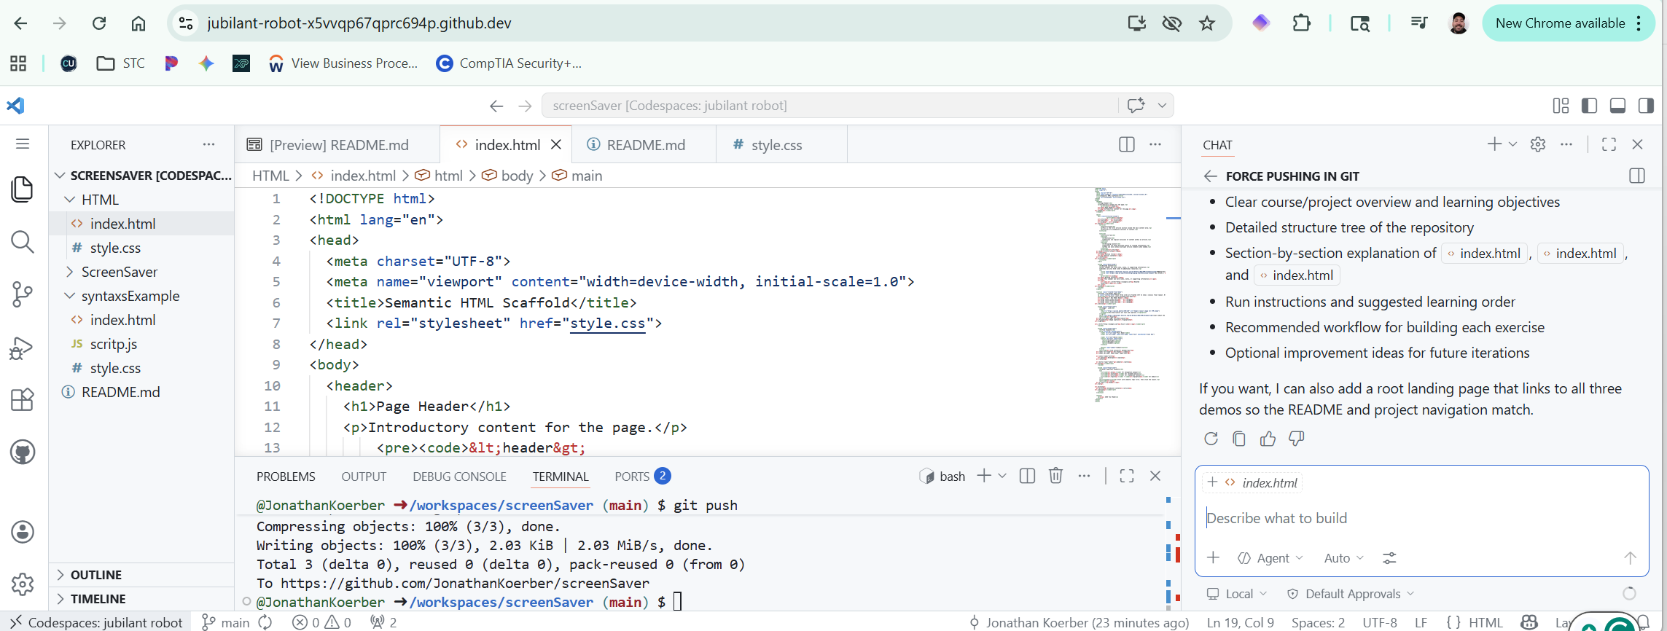
11
22
1
3
4
5
6
- In box 1 often referred as the Gutter, this will chang what show up in box 2. From top to bottom you have a hamburger icon this will close box 2, file explorer, search, git history, debug, plugins, GitHub.
Box 3 are the files that you have opened.
Box 4 is the terminal. You also see that you have tabbed resources like the debug console and ports that you are using.
Box 5 is a file preview. This is nice to see where you are in a file.
Box 6 in Copilot chat agent. If you have any questions about the environment. You can use this to help trouble shoot build templates and write code.
- Right now, it doesn’t have as many files, so let's change that. If you don’t see a terminal, you can click on the search icon in the gutter and search terminal. Don’t worry, we are only going to use a few commands. Lest start with creating our files to do that in the terminal type “touch index.html style.css” this will create two files, one called index.html and another called style.css. Let's open both of these files.
- Open the file index.html. In this file, we are going to use Hypertext Markup (HTML) to create the structure for the web side. HTML isn’t really a programing language, but it is a format that web browsers can read in a then render a web page. To make our site look nive we will have to all use Cascading Style Sheets (CSS) to tell the browser how we want the elements in our HTML file to look like. The browser these two files and adds the data from both files to an internal storage object called Document Object Model (DOM).
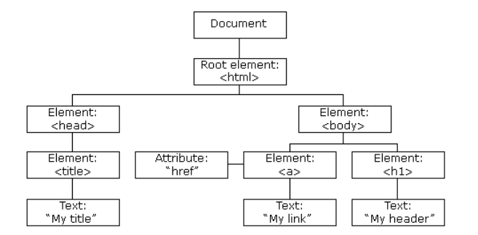
Below is a JavaScript function that we can to any website a read out their DOM object. Go to any website and click on the page and select “inspect” or “inspect element”. Now you can see all the HTML elements. You’ll need to open some up to see inside to see what is happening.
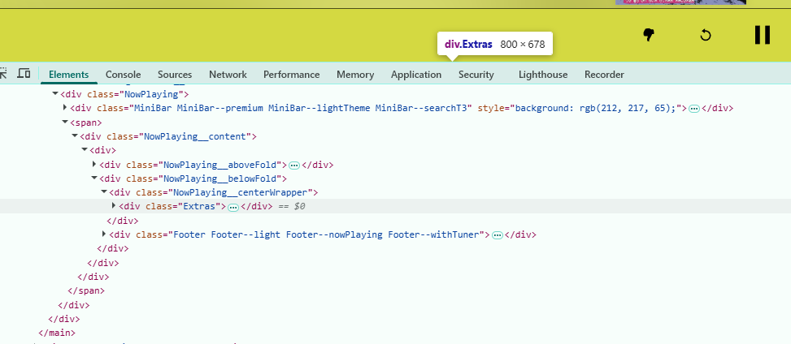
We can print the combined element and style rules with the script below. If you are interested, you can find the console in the inspect element section. Past in the following into the console, then press enter. Next run “readElements(document.body)” This will print the HTML element and the associated CSS rules.

function readElements(element, depth=0){
const indent = " ".repeat(depth * 2);
const computedStyle = window.getComputedStyle(element);
const textContent = element.textContent?.trim() || '';

console.log(`${indent}<${element.tagName.toLowerCase()}>`);

// Only show the actual rendered CSS properties
const importantProps = ['color', 'background-color', 'display', 'font-size', 'padding', 'margin', 'width', 'height', 'border', 'transform'];
const cssValues = importantProps
.filter(prop => computedStyle.getPropertyValue(prop))
.map(prop => `${prop}: ${computedStyle.getPropertyValue(prop)}`)
.join(', ');

if (cssValues) {
console.log(`${indent} CSS ${cssValues}`);
}

if (textContent && element.children.length === 0) {
console.log(`${indent} TEXT "${textContent.substring(0, 50)}"`);
}

Array.from(element.children).forEach(child => {
readElements(child, depth + 1);

});
}

- Ok, let's get into writing some code. Return to the GitHub Codespaces and open the file index.html that we create a basic web page using chat agent to template out our HTML. Use this or something similar; the phrase “Create the semantic elements we need a header main section, a section and a footer.1” You should end up with something like the following.

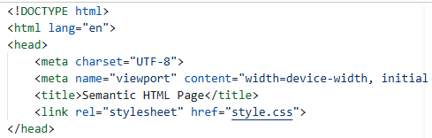
A html file is made up of tags. In the screen shot above, we can see the file declaring its doc type then we see an html tab this wraps the whole document. The head tag is mostly made up of meta data like the character set, the pages title, and a link to the stylesheet. We will come back to this. Take a moment to go a look at the diagram of the DOM. See how it matches up with the tags on in this file. Here we see the body tag. For what we are doing, this is the most important as it is the part of the document as it is what is rendered in the browser.
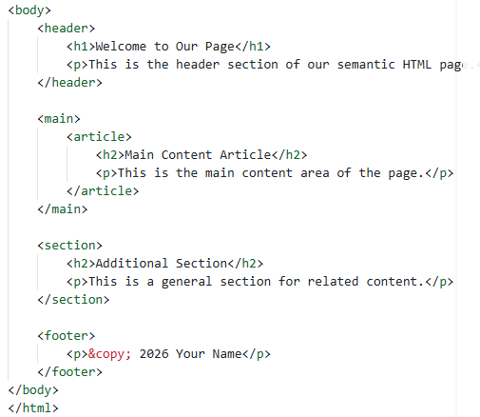
- We are going to run a HTTP server so that we can view the site that we are working on. Let's open the terminal and run the command `python3 –m http.server 8000`. You’ll get a popup message saying that your application is running. Click to open in the browser.
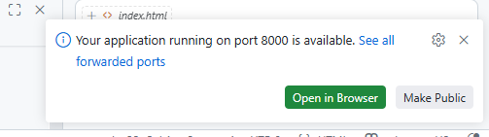
Go to your page and you can see what we have so far. This is just the HTML content and is not yet styled at all. Have a quick look at your code and left click inspect. You will need to click each tag to open them.
- Net we are going to go back to our index.html file. Let's go into the main section. Here we are going to add an aside element. Got to your code and add the following.
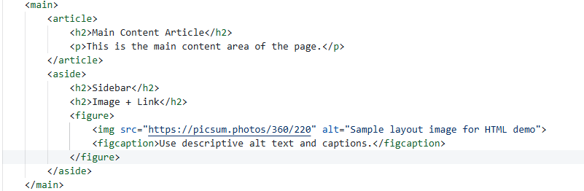
- Next let's go into the section under main and add change the section to the following code:
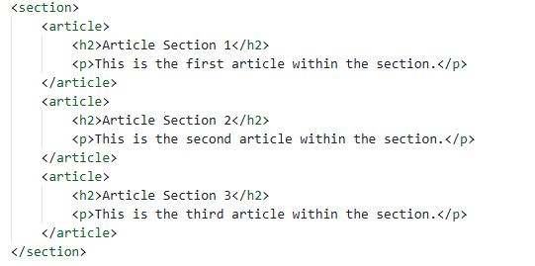
**Note that we have been using semantic elements. You could use a <div> instead, and it would be rendered the same way visually. However, semantic elements (like <main>, <article>, or <aside>) give added meaning to the markup. They help us as developers understand the structure of our code and help accessibility devices, such as screen readers, understand the type of content they are processing.

- If you go to view the changes, you will need to refresh the page. Make sure that everything is rendered without errors. Next, we will add some CSS style rules to make the site look a little better refer to reading from more context or take a quick look at CSS Box Model.

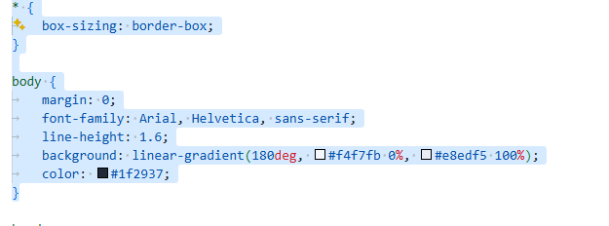
Many CSS rules are for the most part self-explanatory. If you are wondering what a rule is doing, use the AI chat agent to give more details. Also look as if the rules change the site.
- Next, we are going to add a style rule to multiple elements in our html file. This sets the background, width, margin, and corner radius. It also creates a border and adds a shadow. 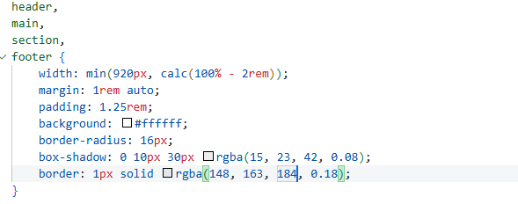
- Next, we’ll style just the header.
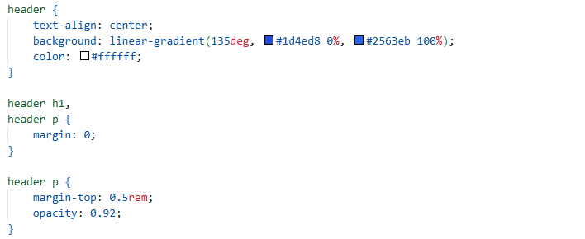
- Next, we will set rules to assign columns for the article and aside inside the main element. We can target multiple elements by using the root element followed by the child element that you are trying to target.
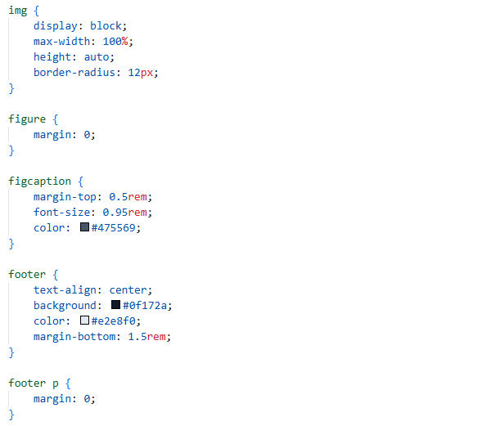
- Next, we are going to use a media query. This will change the style rules; the width of the screen is less than 720 pixels. This reset the rules in the main section to be one column rather than two columns.
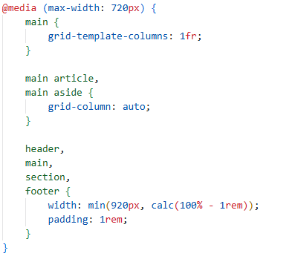

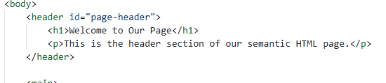
- If we have a unique element that we want to assign a style rule to, we can use and ID. To do this go to the html file and we add the ID to header like below.
Then in style.css we can add reference to this element in the with a `#` in front of the id.
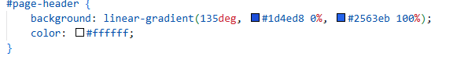
- If we want to target more than one element with a rule, we can use a class name. This we can use this on multiple elements. Using classnames is different to assess an element by its tag name, as you can apply a class name to two direct element types. A use case would be is you want to grey out elements that are not available.
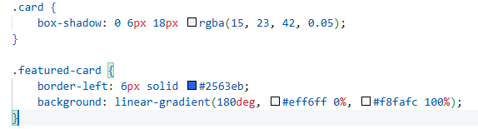
Class names in CSS use a period in front of the class name. Add both class names to the article inside of the main. Then add just the class card to all three articles inside the section under the main.
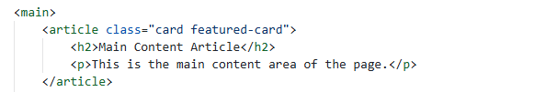
Check that your wit looks like the example below. Feel free to experiment
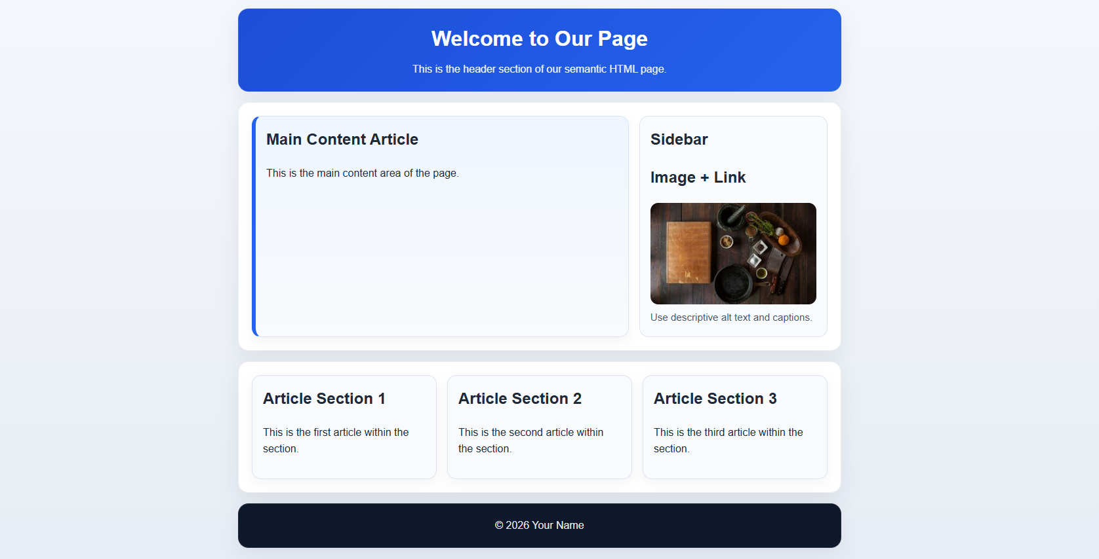Upload the folder to the GitHub repository.
git add --all
git commit -m “HOS01 – your name”
git push
Check in your repo to make sure that your changes are visible.

